Balance here, balance there,
Balance, balance everywhere.
Balance when I'm standing,
Balance when I'm walking,
Balance with a balance point,
Balance with the help from counterweight.
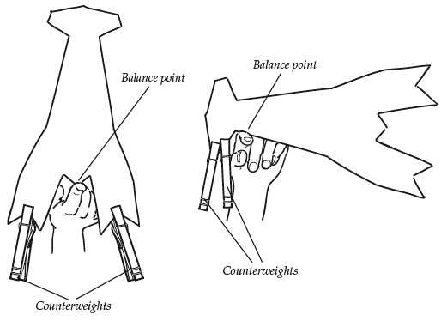
Balance here, balance there,
Balance, balance everywhere.
Crayfish balancing on a finger,
Arches and triangles positioned right do too,
Clothespin counterweights keep things stable and balanced,
But unstable objects do not balance.
Balance here, balance there,
Balance, balance everywhere.
Balance! Balance! Balance!
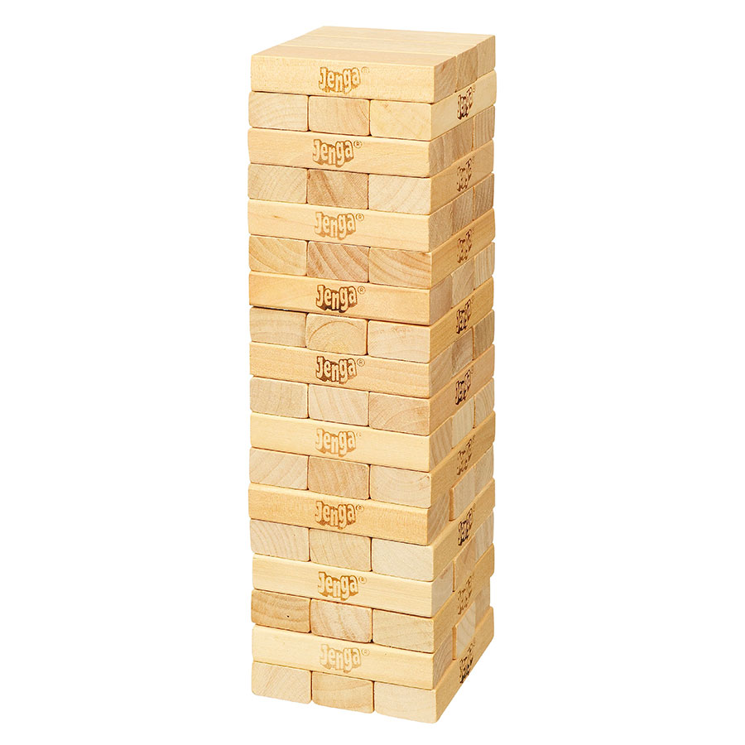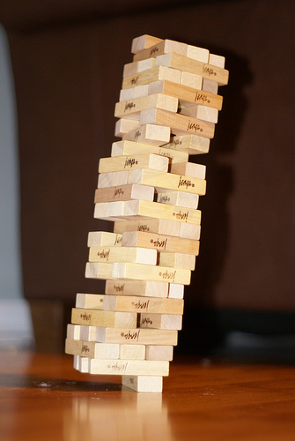
stable unstable

